Year End Process Phase-2 Documentation

- Login to FIN application.
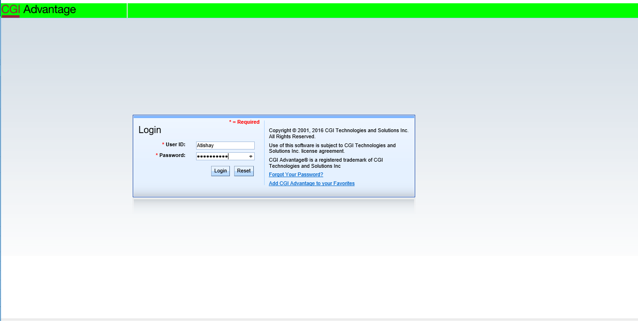
- Update MESG table- Set ME216 to Warning
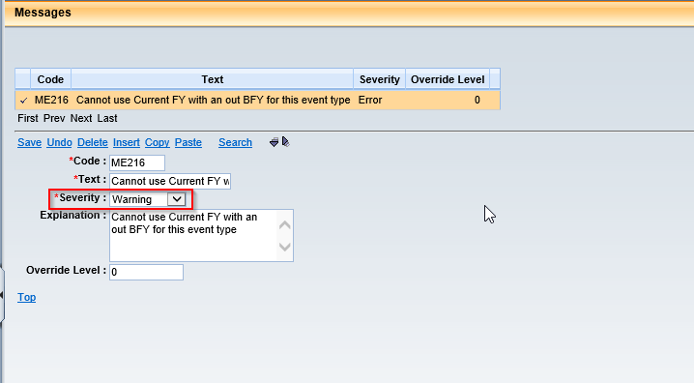
- Update APPCTRL table.
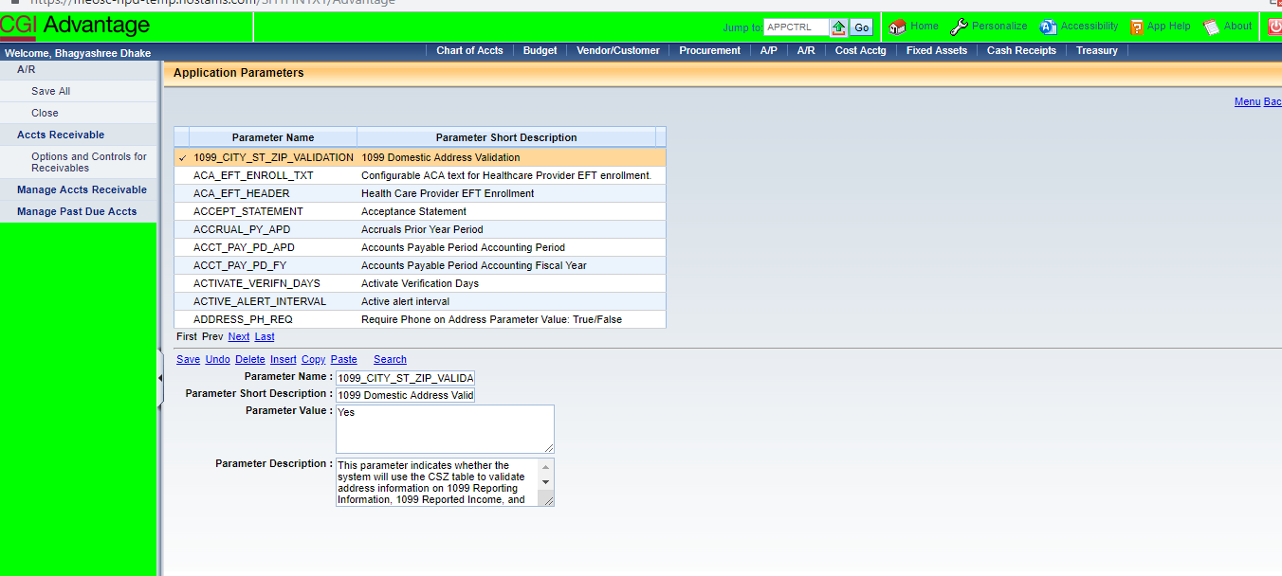
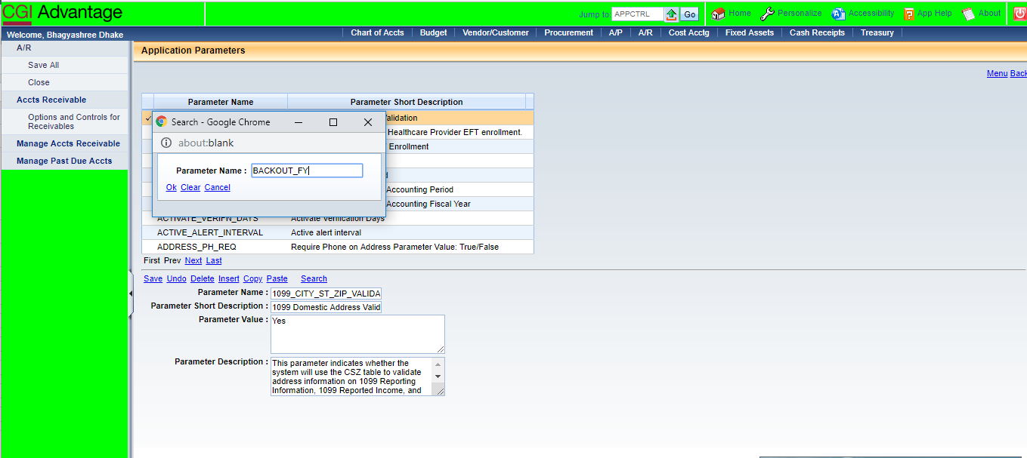
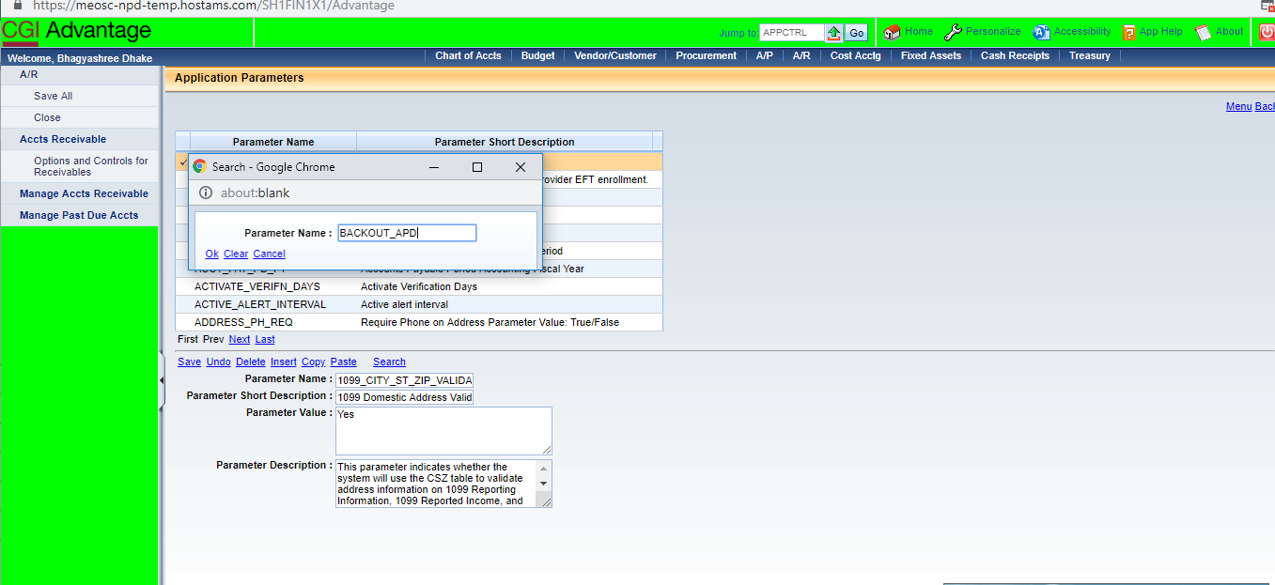

NOTE: Server should be Bounced when any APPCTRL parameters are updated.
- Login to FIN Application.

- Update DCTRL setup for BPO, CT, CTB, CTM, DO and PO documents.
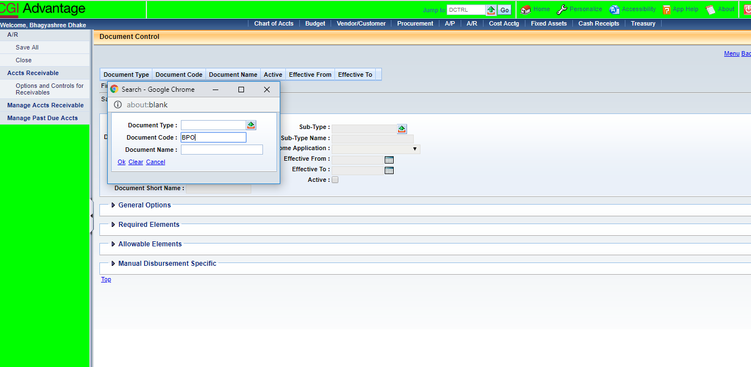
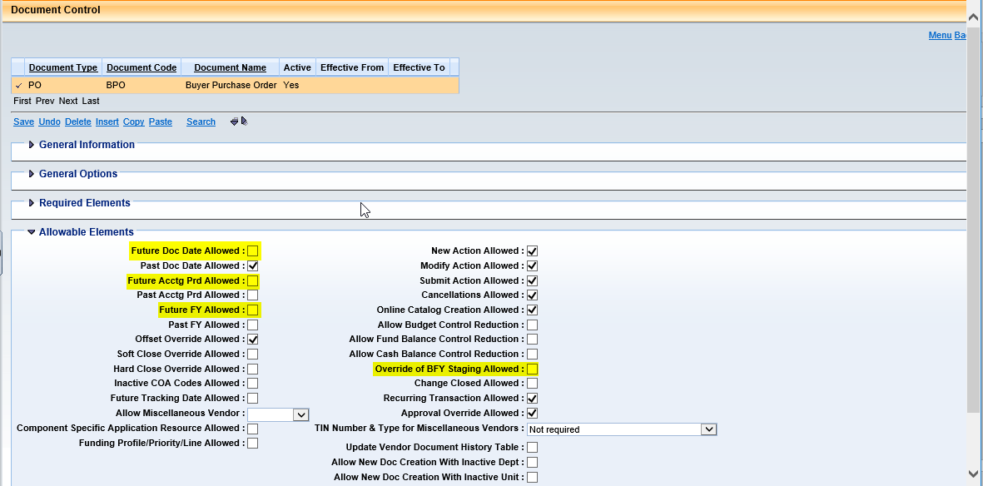
NOTE: The DCTRL setup for rest of the documents is similar.
- Schedule SysManUtil (System Maintenance Utility) job
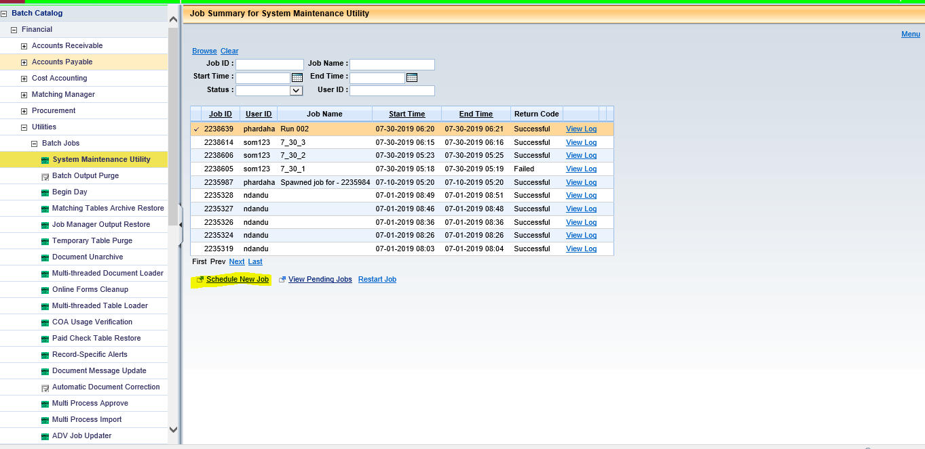
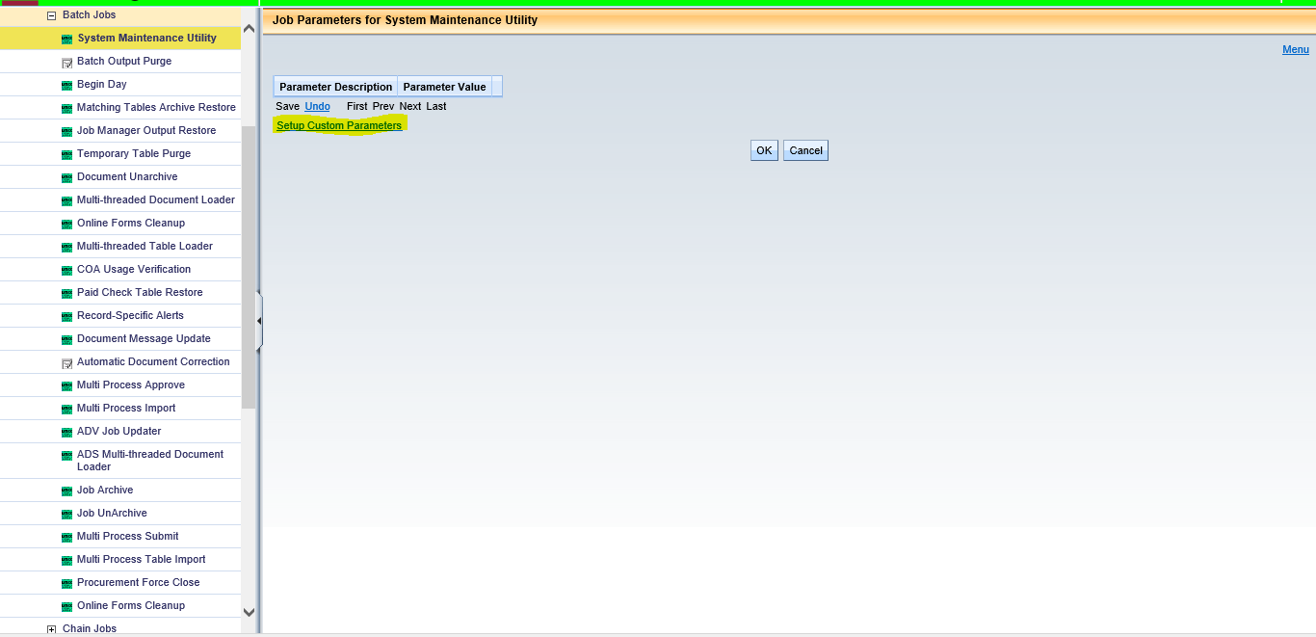

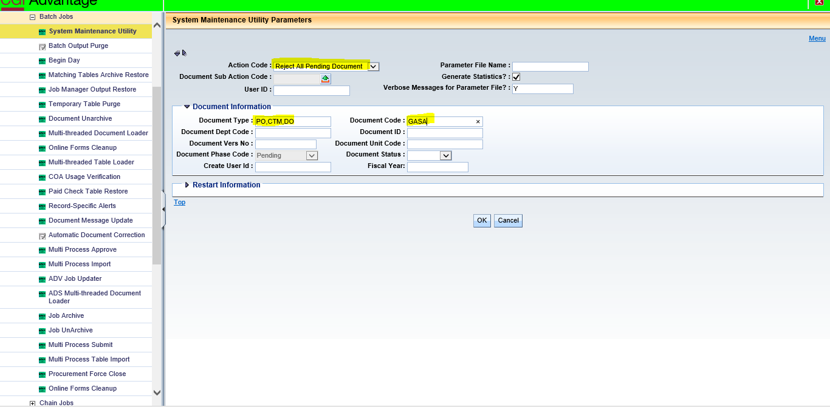

- Update MESG table- Set A6351, A1506, A1591 and A1592 severity to “Information”.
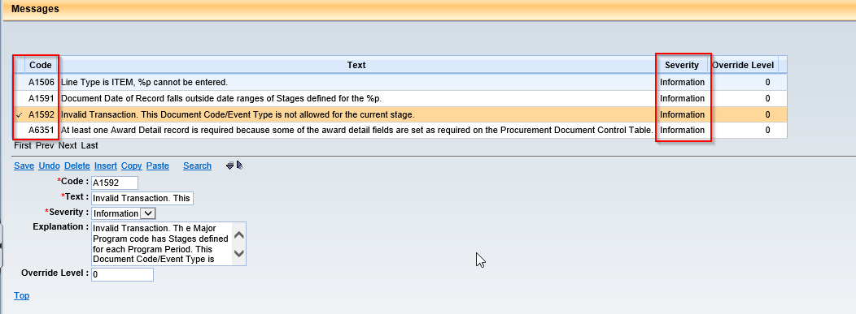

- Schedule the Contract Roll Chain Job. (Create and Load Only. Disable 2,3 and 4 jobs of chain)
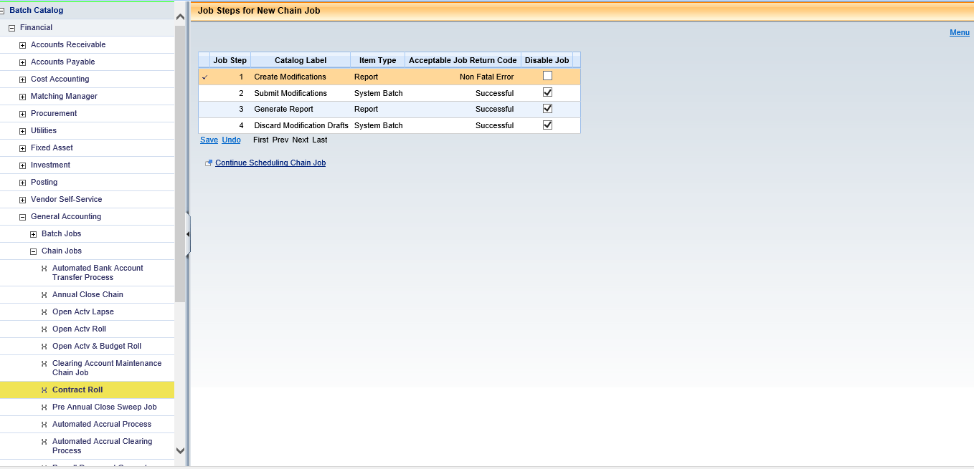
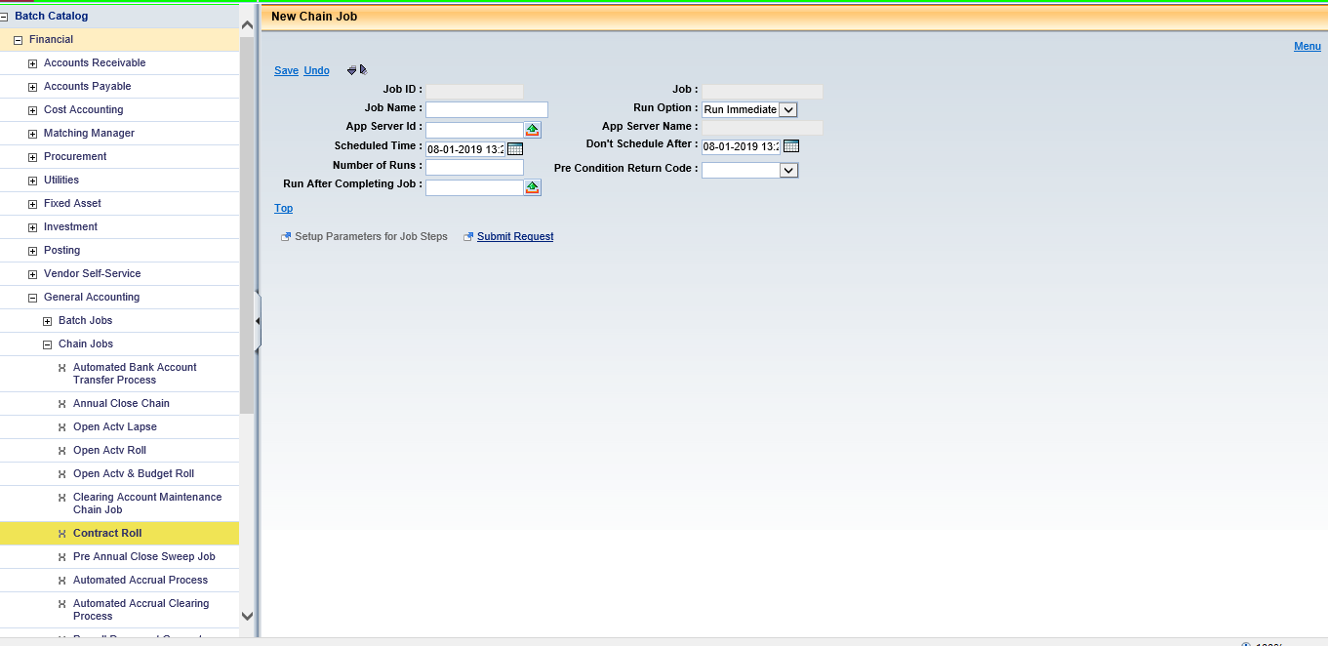
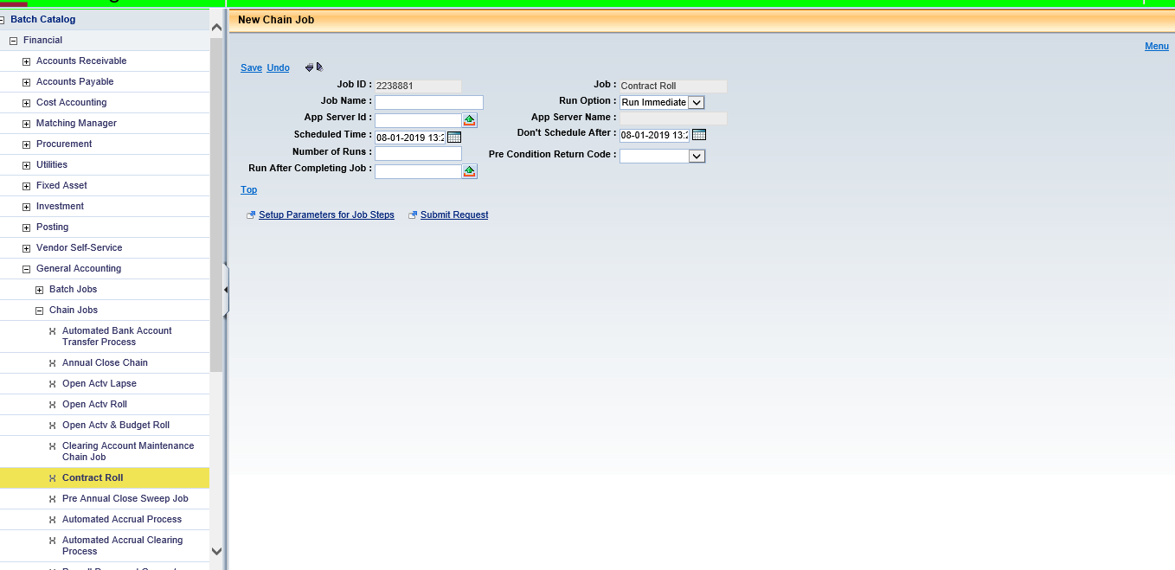
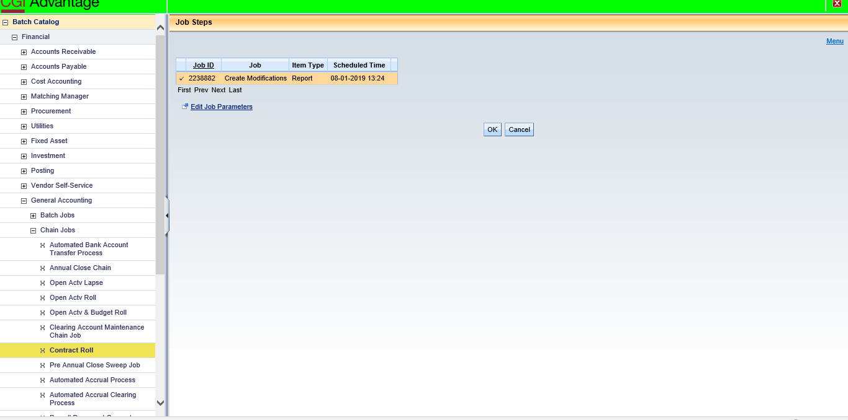
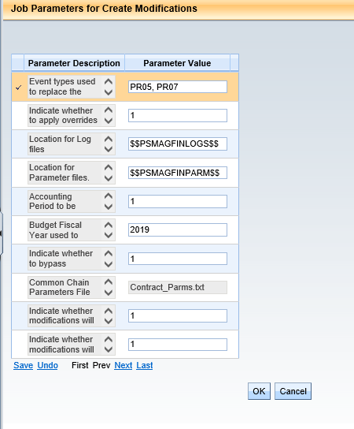
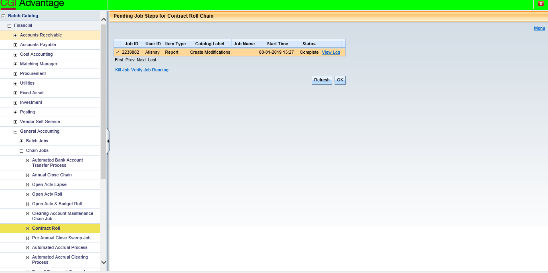

- Schedule Contract Roll Chain Job- (Submit Only. Disable 1 and 4 jobs in chain)
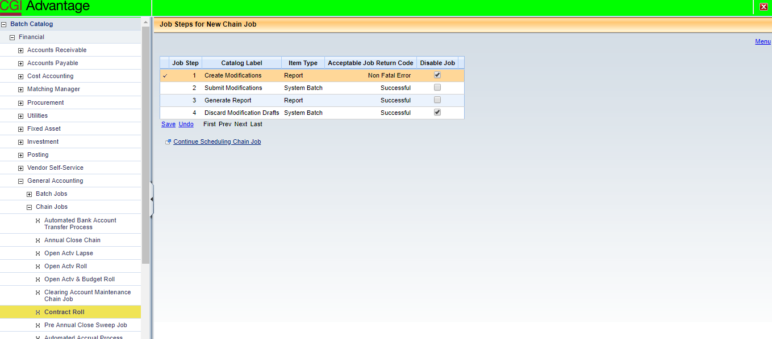

Open Activity Roll – PR07 Lines
- Update DCTRL setup for BPO, CT, CTB, CTM, DO and PO documents.
NOTE: The DCTRL setup for rest of the documents is similar.
- Verify APPCTRL setup
BACKOUT_FY
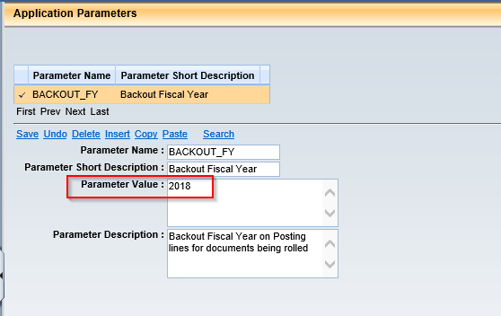
BACKOUT_APD
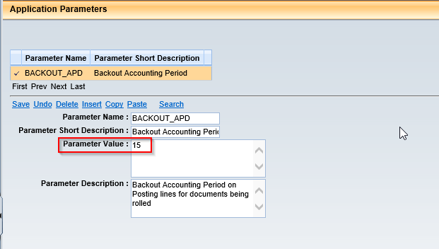

NOTE: Bounce servers if APPCTRL parameters changed.
- Schedule SysManUtil (System Maintenance Utility) batch job

- Update RLPA table
Parm ID =1
Closing BFY = 2018
Run Mode = Report Only
Event Type Selection = PR07
Document Code = BPO,CT,CTM,CTB,CTMV,DO, PO
Mod FY = 2019
Mod APD = 1
Adj Reason = YEROLL

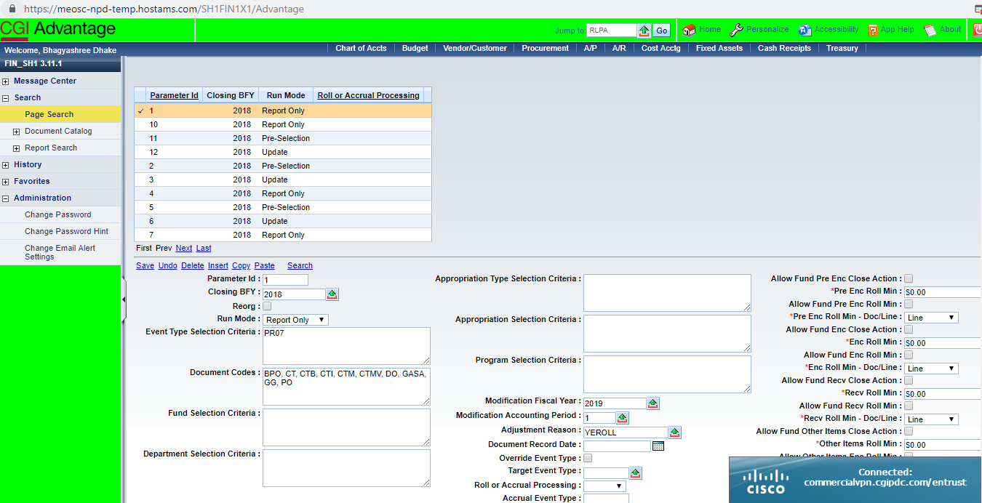

- Schedule Open Activity Roll job in Report Only mode.
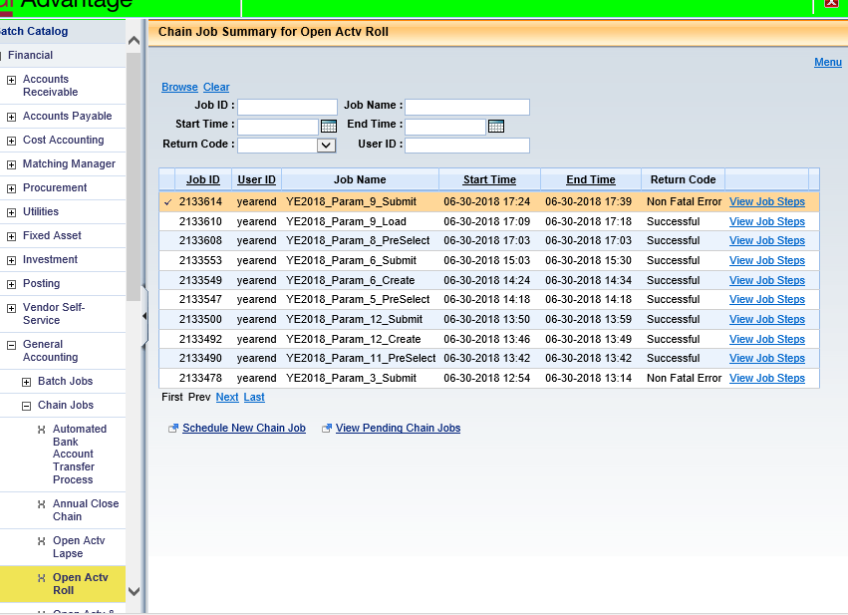
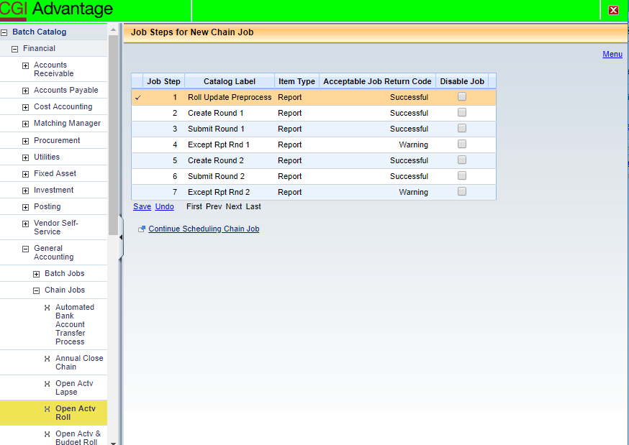

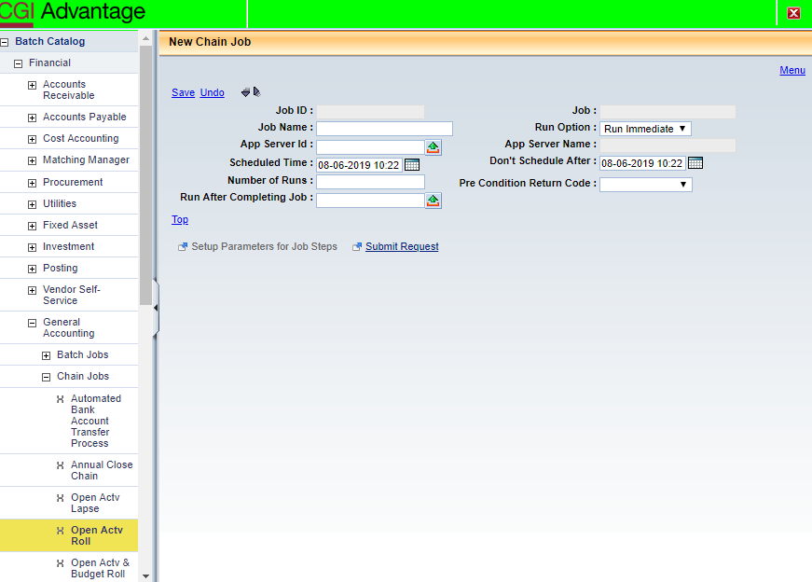

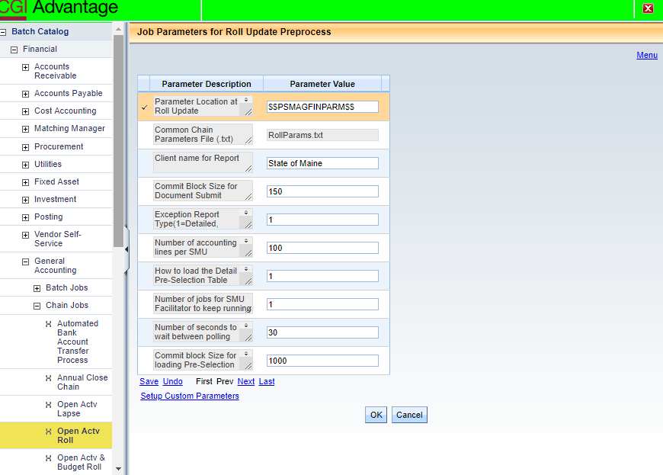

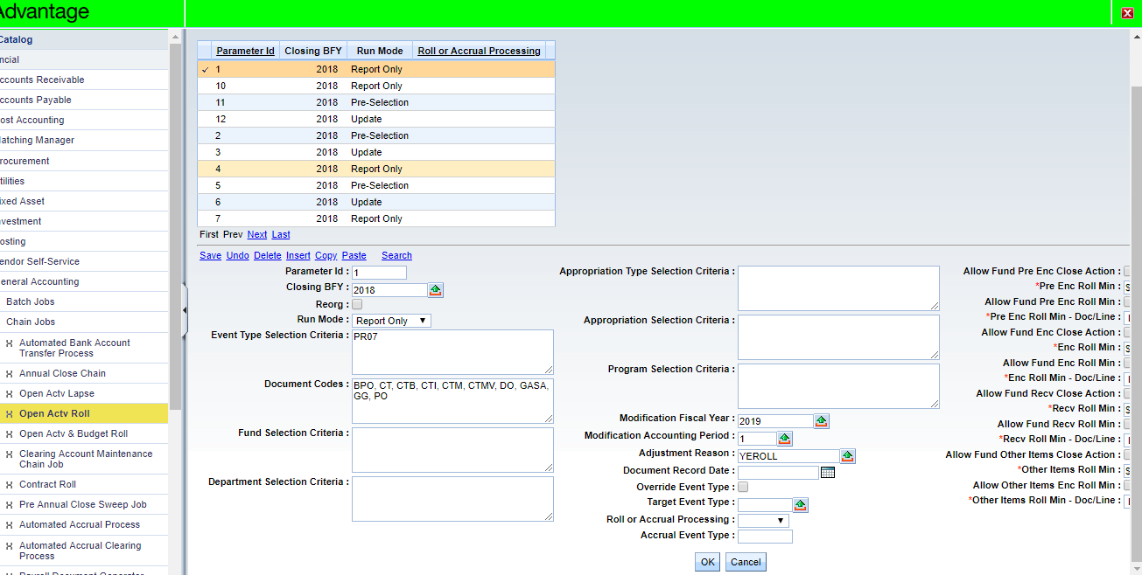

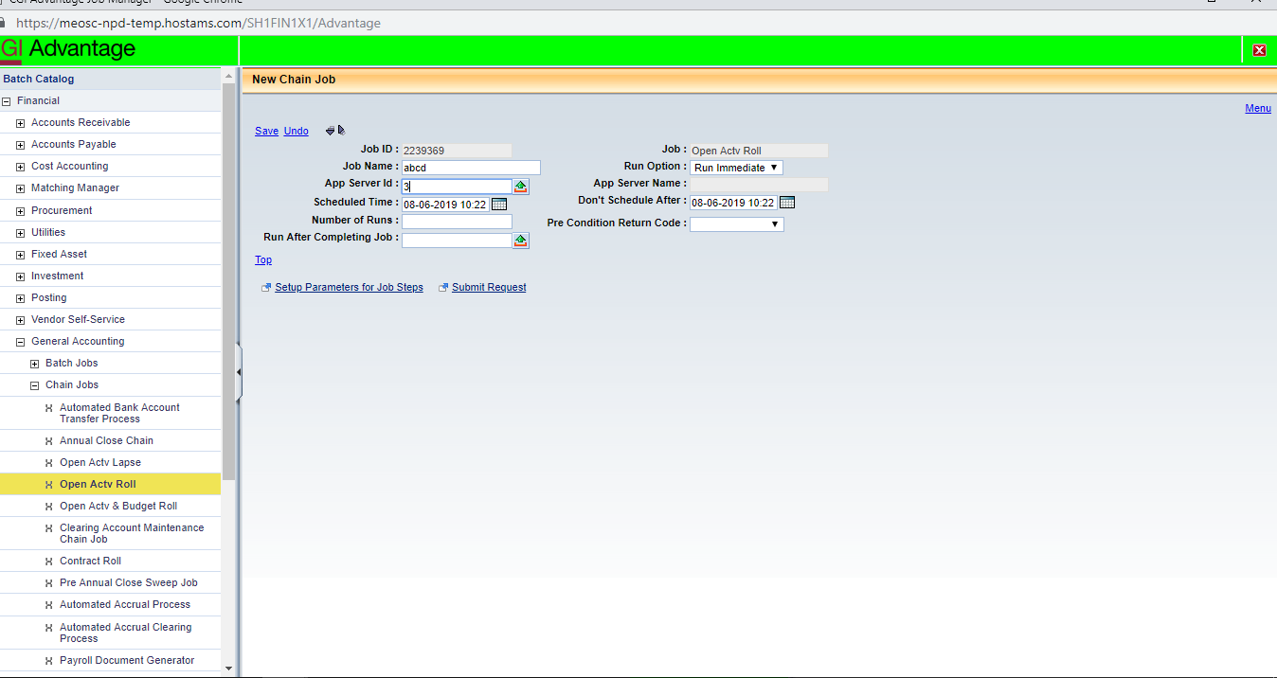

- Setup RLPA table as below:
Parm ID = 2
Closing BFY = 2018
Run Mode = Pre-Selection
Event Type Selection = PR07
Document Code = BPO, CT, CTB, CTI, CTM, CTMV, DO, GASA, GG, PO
Mod FY = 2019
Mod APD = 1
Adj Reason = YEROLL
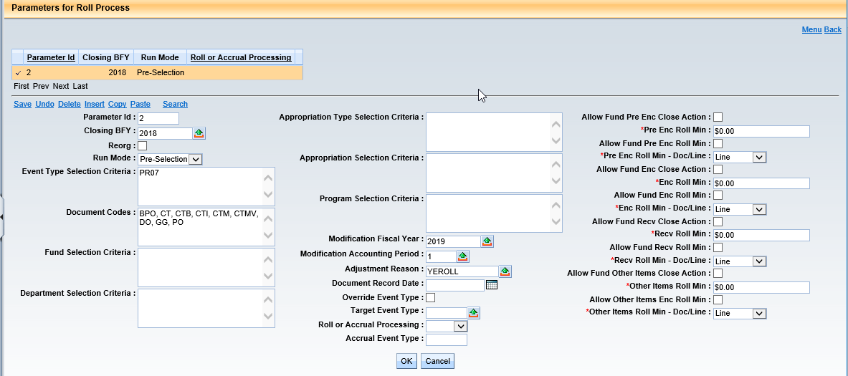

- Schedule Open Activity Roll Chain job in Pre Select Mode. (Disable all jobs except 1)
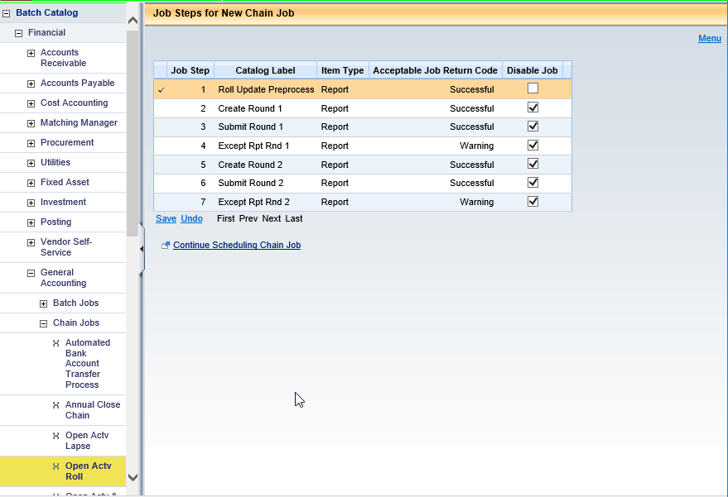

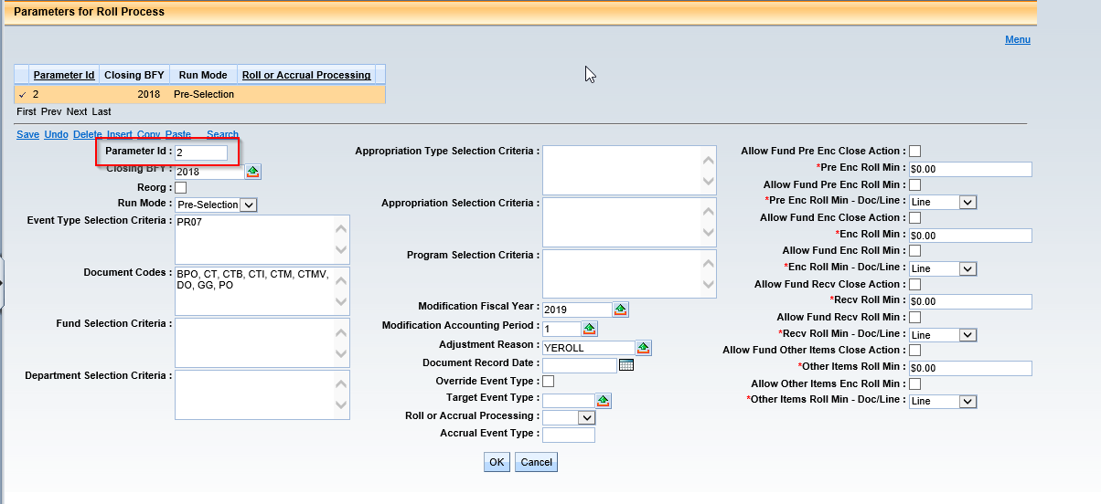

- Review RLPSD table and deselect any items that should not roll.
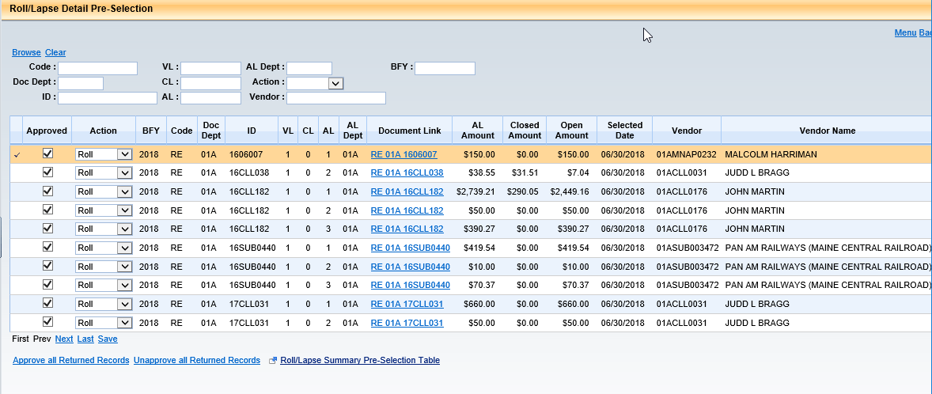

- Setup RLPA table as below:
Parm ID = 3
Closing BFY = 2018
Run Mode = Update
Event Type Selection = PR07
Document Code = BPO, CT, CTB, CTI, CTM, CTMV, DO, GASA, GG, PO
Mod FY = 2019
Mod APD = 1
Adj Reason = YEROLL
Doc Rec Date = 07/01/2018
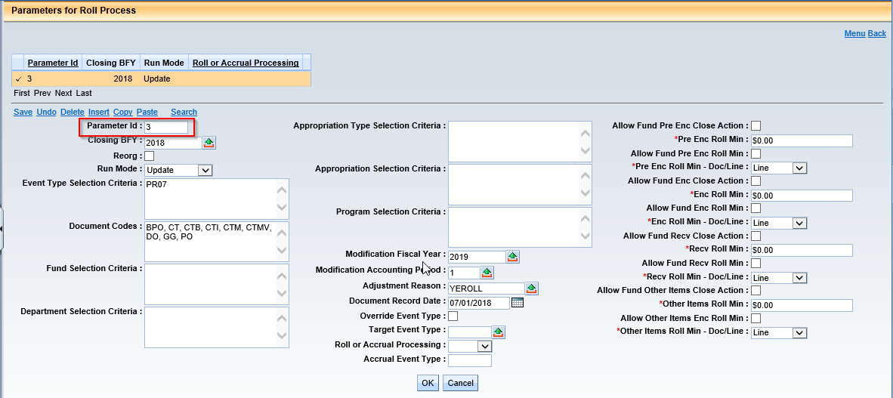

- Schedule Open Activity Chain job in Update Mode. (Deactivate 6 and 7 jobs in chain)

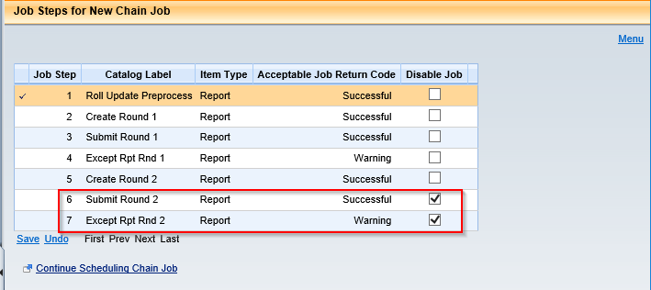

- Schedule Open Activity Chain job in Update Mode to submit documents. (Activate 6 and 7 jobs in chain)

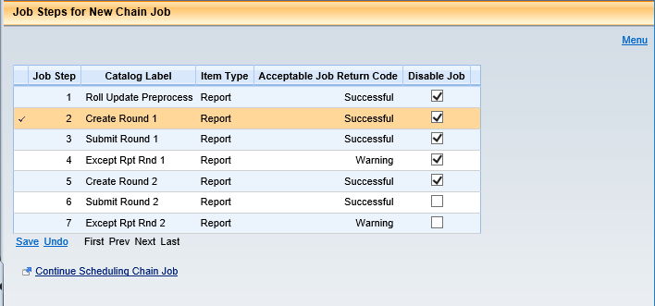

Open Activity Roll – GASA:

- Reject all pending GASA documents from Document Catalog.
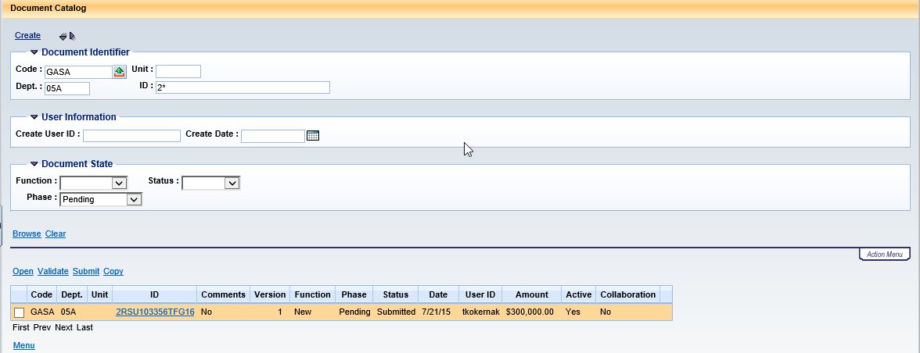

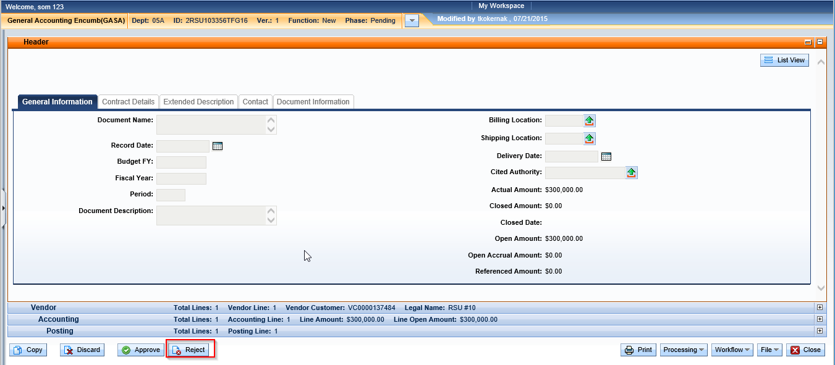

- Setup RLPA table as below:
Parm ID = 10
Closing BFY = 2018
Run Mode = Report Only
Event Type Selection = PR05
Document Code = GASA
Mod FY = 2019
Mod APD = 1
Adj Reason = YEROLL
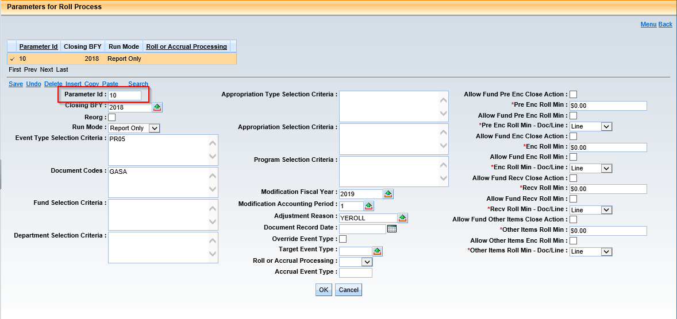

- Schedule Open Activity Roll Chain job in Report Only Mode.

- Setup RLPA table as below:
Parm ID = 11
Closing BFY = 2018
Run Mode = Pre-Selection
Event Type Selection = PR05
Document Code = GASA
Mod FY = 2019
Mod APD = 1
Adj Reason = YEROLL
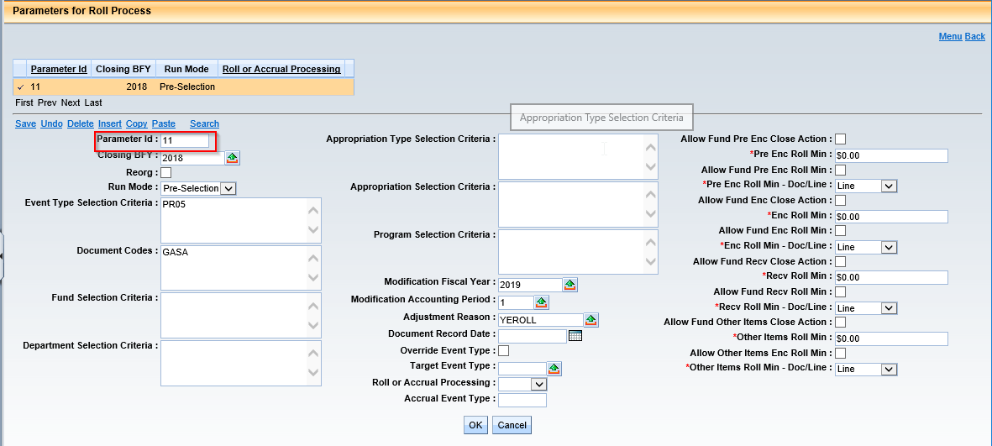

- Schedule Open Activity Roll Chain job in Pre-Select mode. (Disable all jobs except 1)

NOTE: Rest of the steps are similar to Open Activity Roll –PR07 lines

Open Activity Roll – PR05 to PRM5
- Setup RLPA table as below:
Parm ID = 4
Closing BFY = 2018
Run Mode = Report Only
Event Type Selection = PR05
Document Code = BPO, CT, CTM, CTMV, DO
Mod FY = 2019
Mod APD = 1
Adj Reason = YEROLL
Override event type flag = TRUE
Target Event Type = PRM5
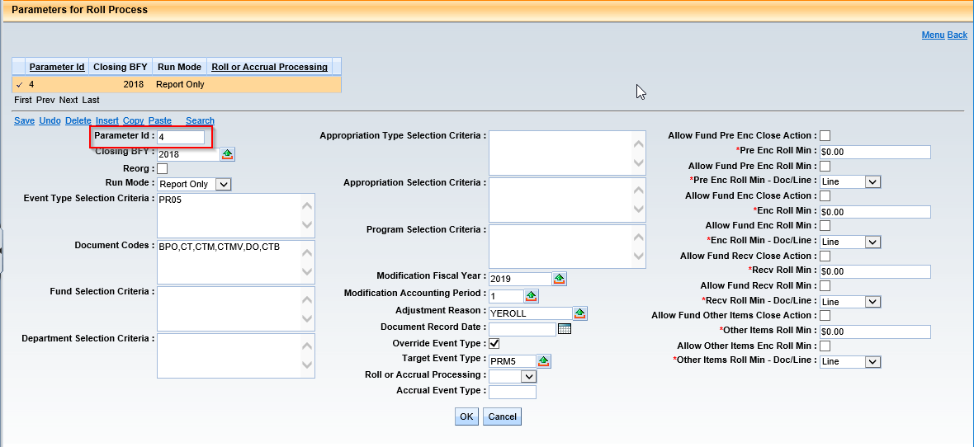

- Update MESG table – Set A3809 severity to “Information”.
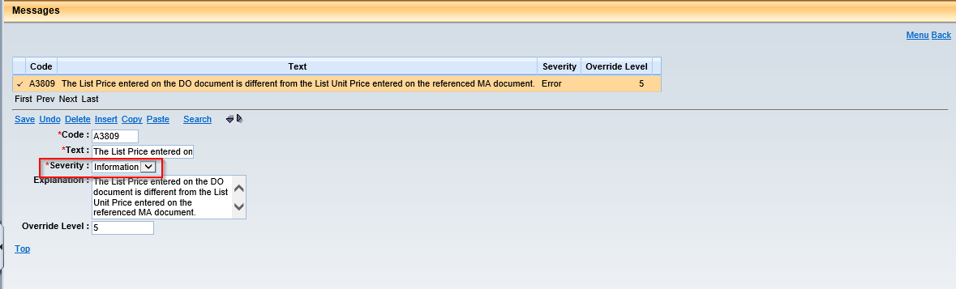

- Reject all pending documents (BPO, CT, CTM, DO) from Document Catalog.
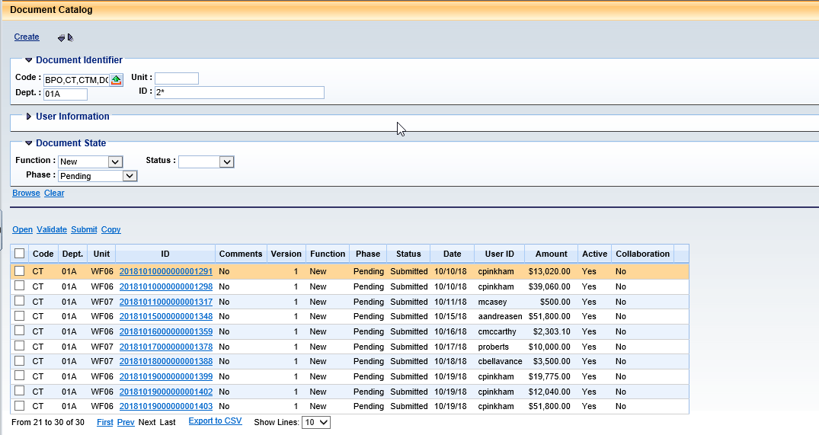

- Schedule Open Activity Roll Chain job in Report Only Mode.

NOTE: Rest all steps are similar to Open Activity Roll –GASA

- Update DCTRL for GASA and PO as below:
Future Doc Date Allowed = False
Future Acctg Prd Allowed = False
Future FY Allowed = False
Override BFY Staging Allowed = False
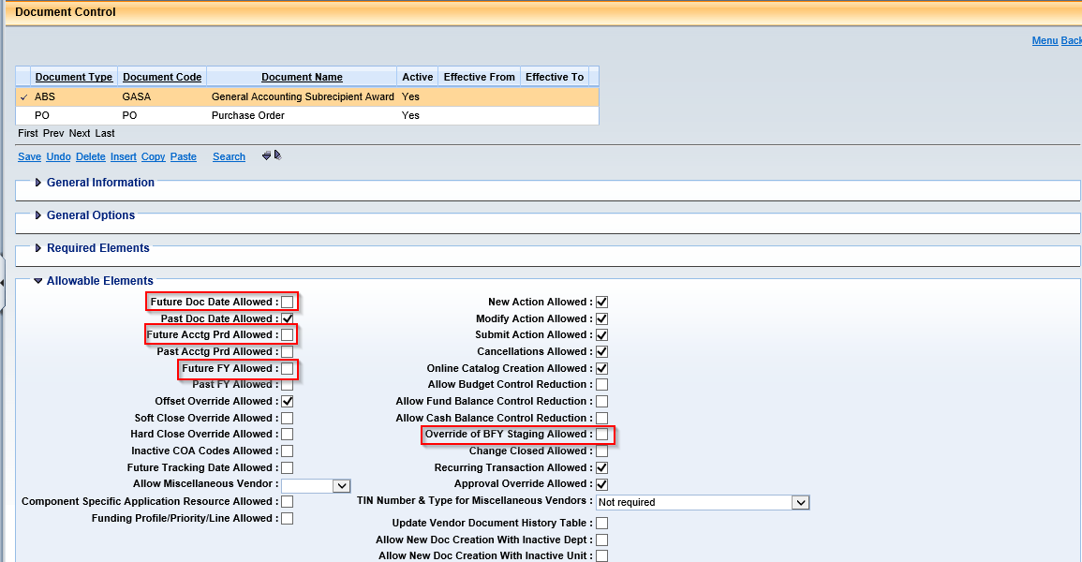

Open Activity Roll – PR86 to PRM6:

- Setup RLPA table as below:
Parm ID = 13
Closing BFY = 2018
Run Mode = Report Only
Event Type Selection = PR86
Document Code = BPO, CT, CTMV, DO
Mod FY = 2019
Mod APD = 1
Adj Reason = YEROLL
Override event type flag = TRUE
Target Event Type = PRM5
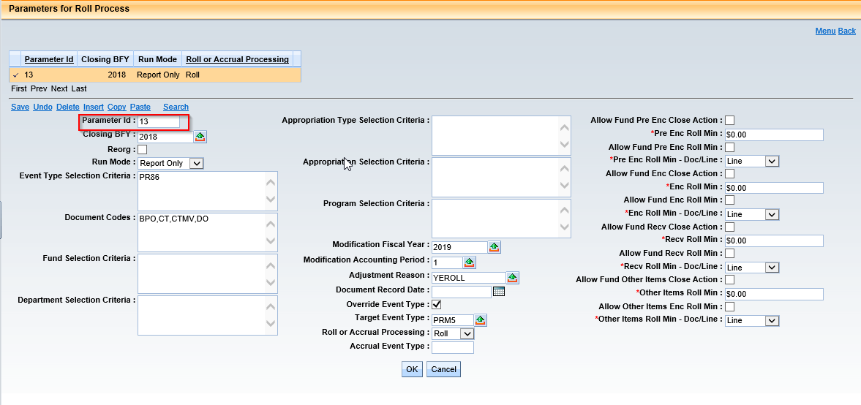

- Reject all pending documents (BPO, CT, CTM, DO) from Document Catalog.

- Schedule Open Activity Roll Chain job in Report Only Mode.

NOTE: Rest all steps are similar to Open Activity Roll –GASA

- Update DCTRL for BPO, CT, CTM, CTB, CTMV, DO, GASA, PO as below:
Future Doc Date Allowed = False
Future Acctg Prd Allowed = False
Future FY Allowed = False
Override BFY Staging Allowed = False

Open Activity Lapse – PR05:

- Update DCTRL for ABDL, CBDL as below:
Vendor = Optional
Time Restriction Severity = Override
Time Restriction = No Limit
Override BFY Staging Allowed = True
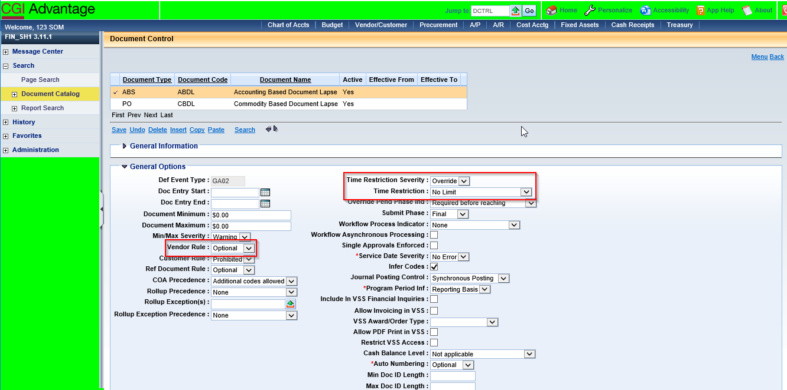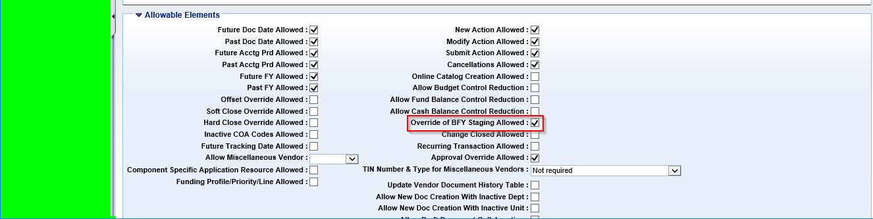

- Update PROGREQ for all listed records
Program = Optional
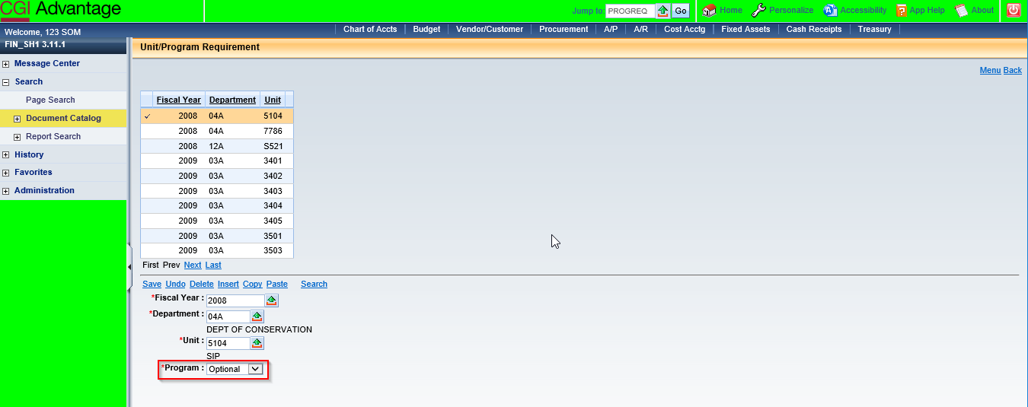

- Update MESG table – Set A5074 severity to “Information”
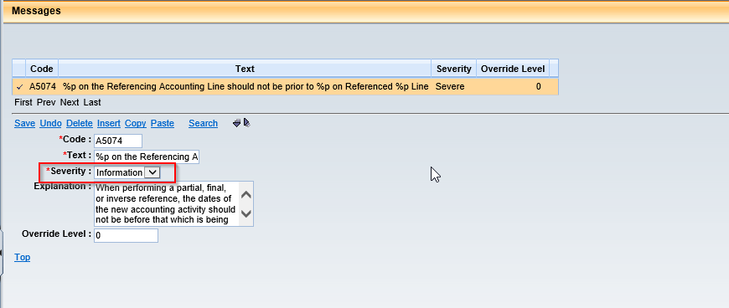

- Add CBDL document to PRCUTYP 18 award section.
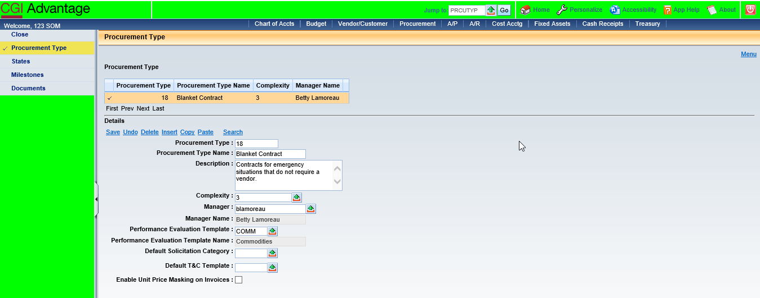
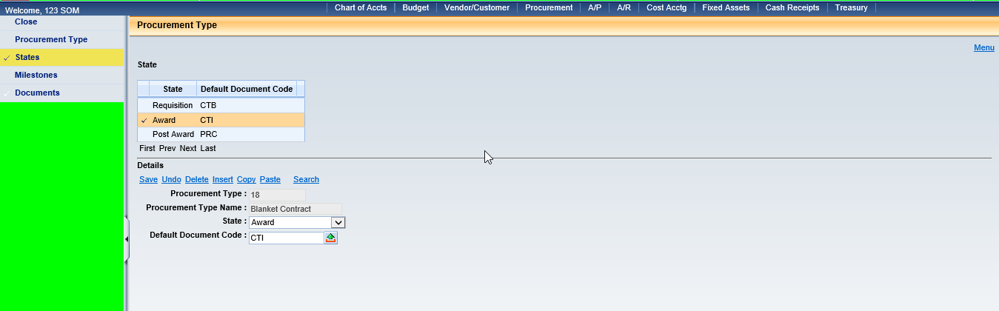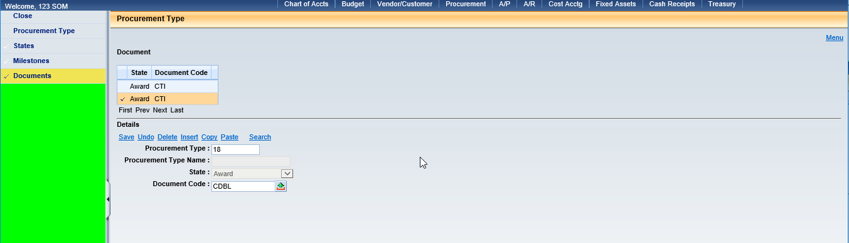

- Setup LPPA table as below:
Parm ID = 1
Closing BFY = 2018
Run Mode = Report Only
Doc Code = GAE, BPO, CT, CTI, CTM, DO, CTB, CTMV
Event Type Selection = PR02, PRM5, PRM6
Fiscal Year = 2018
Accounting Period = 15
Doc Record Date = 06/30/2018
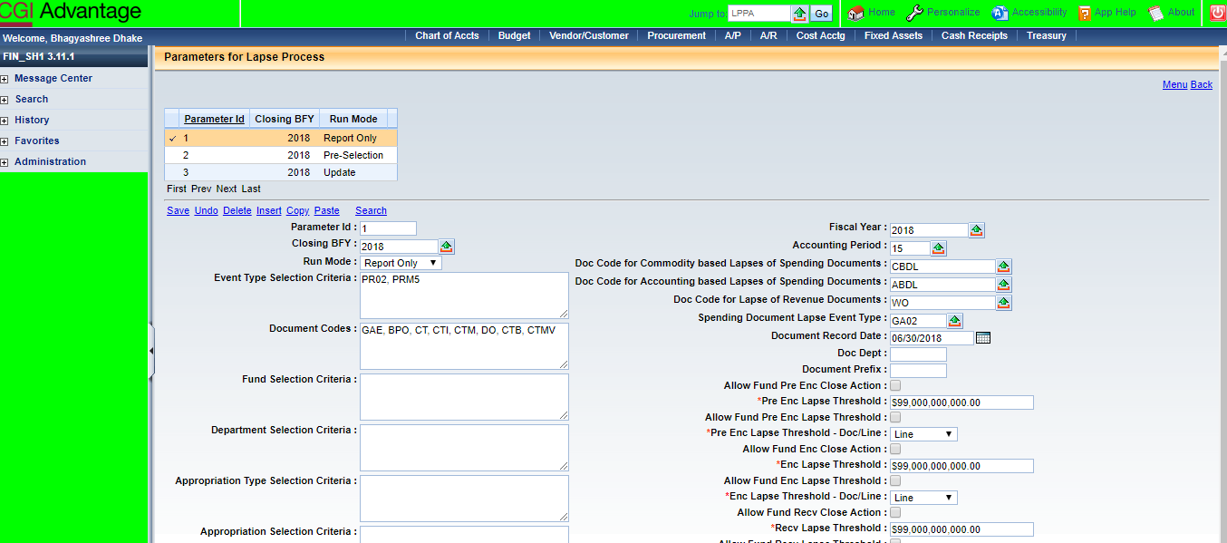

- Schedule Open Activity Roll Chain job in Report Only Mode.
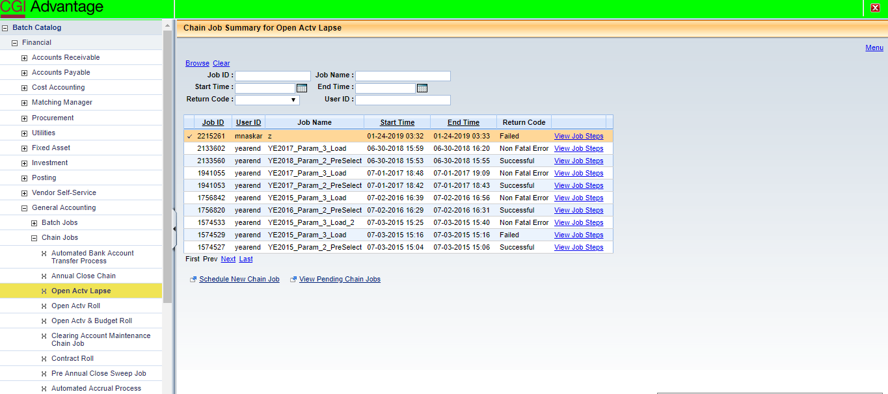

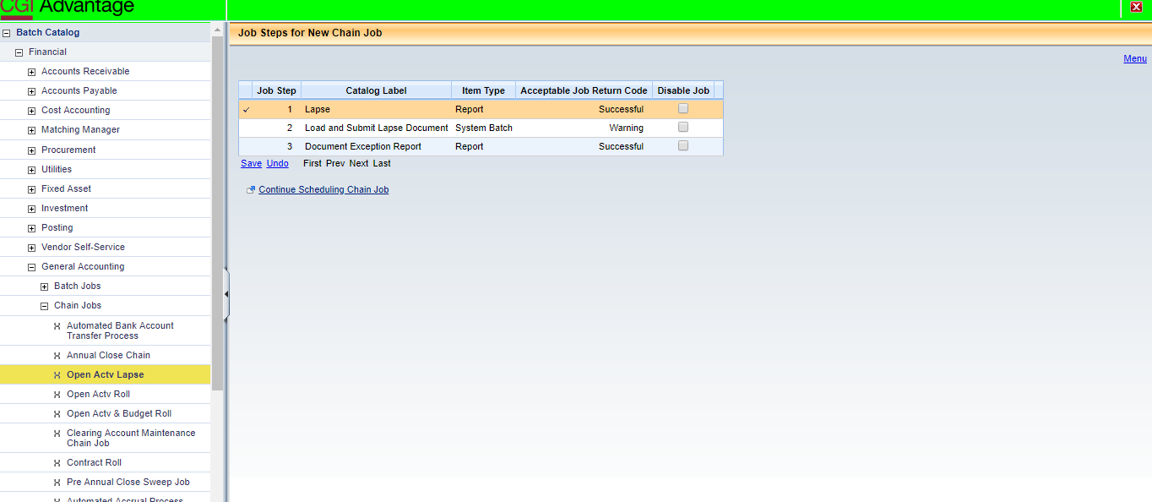

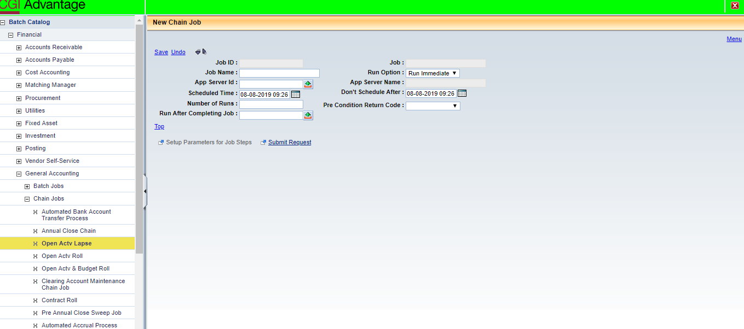

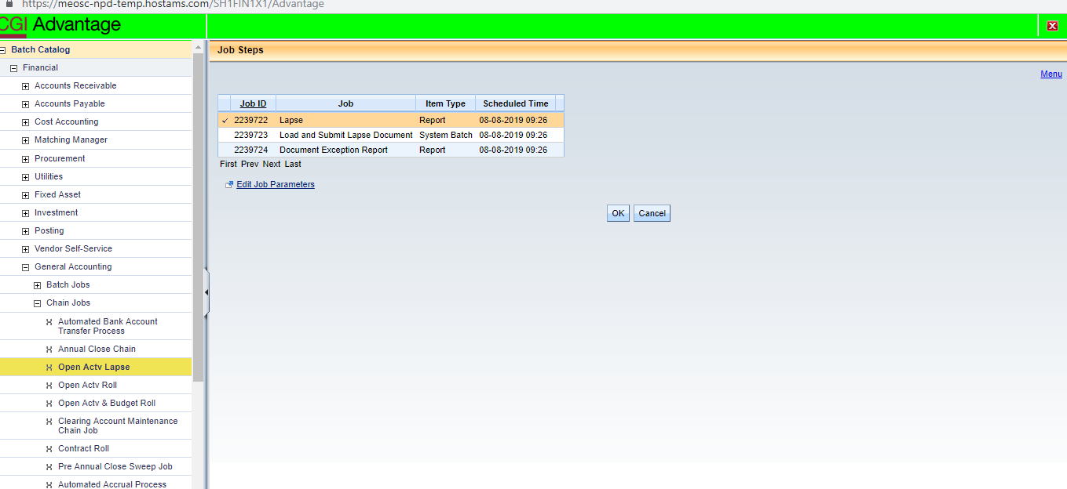

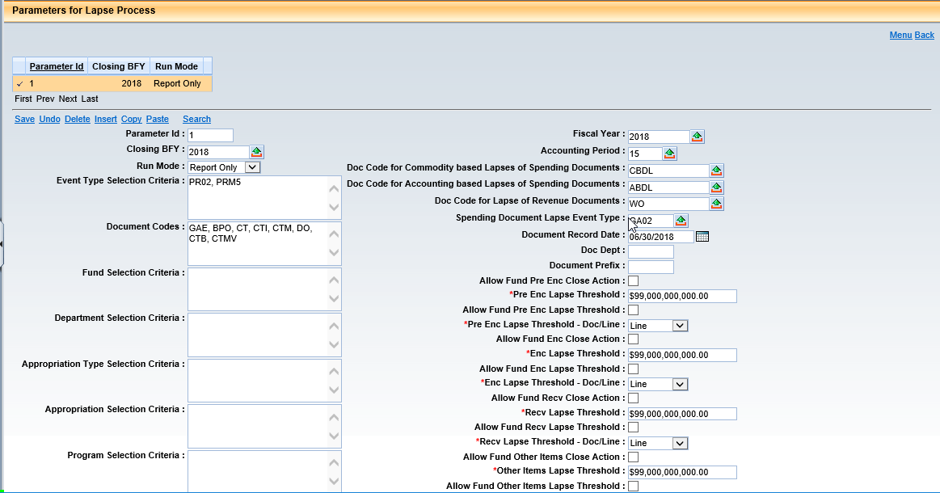

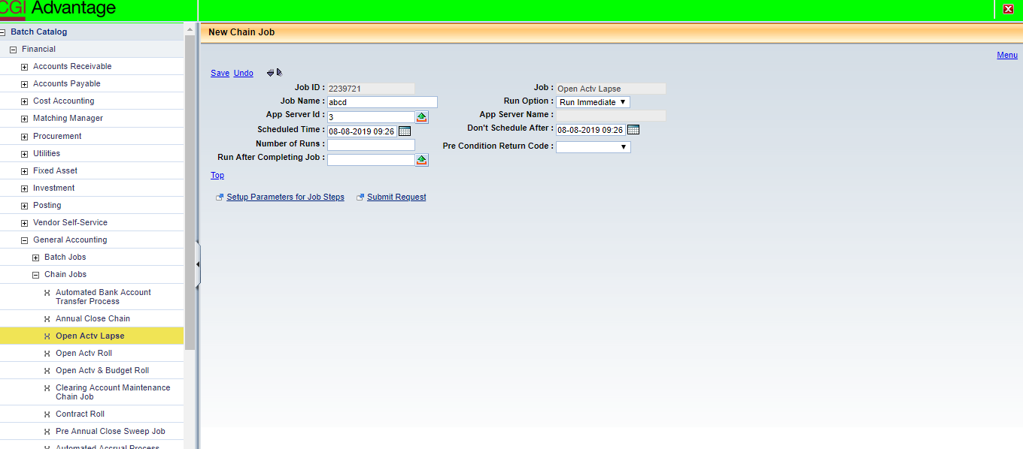

- Setup LPPA table as below:
Parm ID = 2
Closing BFY = 2018
Run Mode = Pre-Selection
Doc Code = GAE, BPO, CT, CTI, CTM, DO, CTB, CTMV
Event Type Selection = PR02, PRM5, PRM6
Fiscal Year = 2018
Accounting Period = 15
Doc Rec Date = 06/30/2018
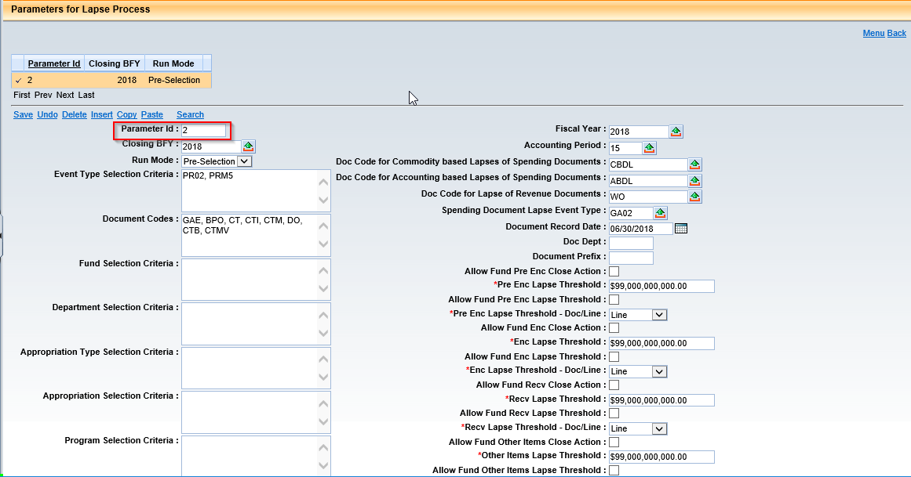
- Schedule Open Activity Lapse Roll job in pre-Select Mode. (Disable all jobs except 1)

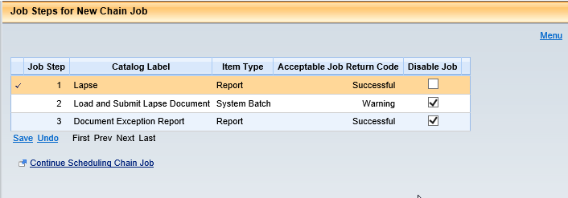

- Review RLPSD table and deselect any item that should not lapse.
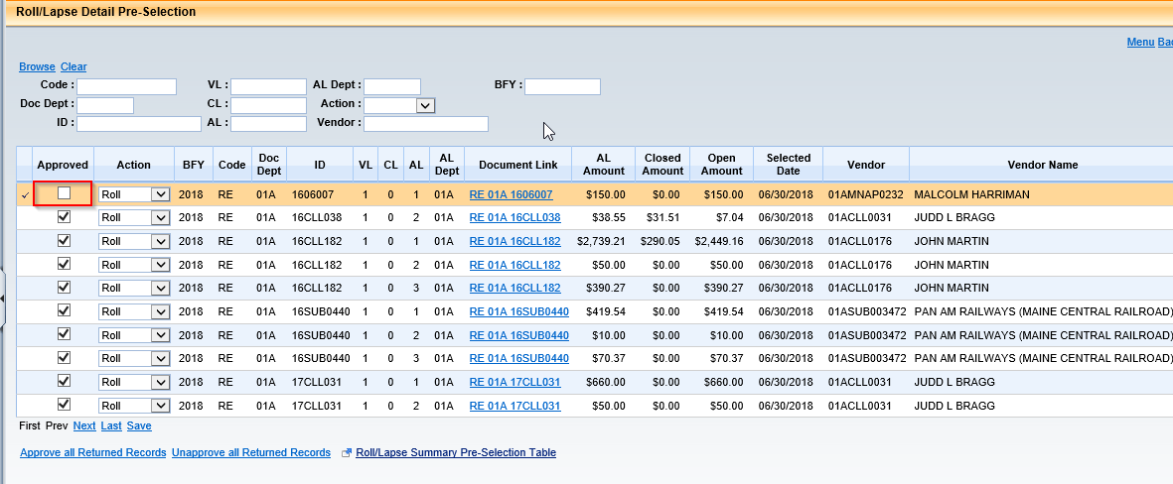

- Setup LPPA table as below:
Parm ID = 3
Closing BFY = 2018
Run Mode = Update
Doc Code = BPO, CT, CTB, CTM, DO, GAE
Event Type Selection = PR02, PRM5
Fiscal Year = 2018
Accounting Period = 14
Doc Rec Date = 06/30/2018
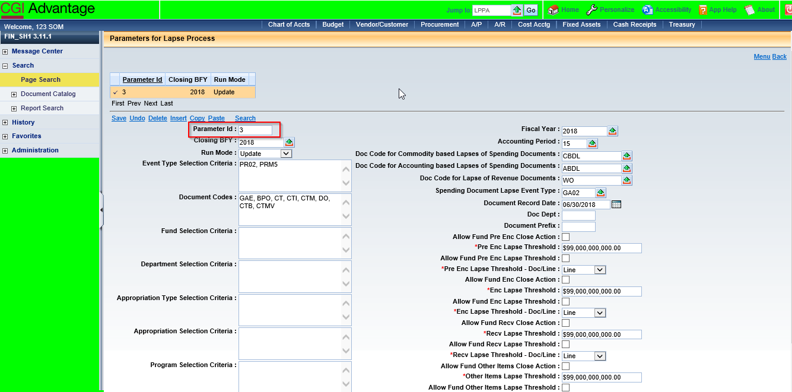

- Schedule Open Activity Lapse job to create and submit documents (No Jobs disabled)

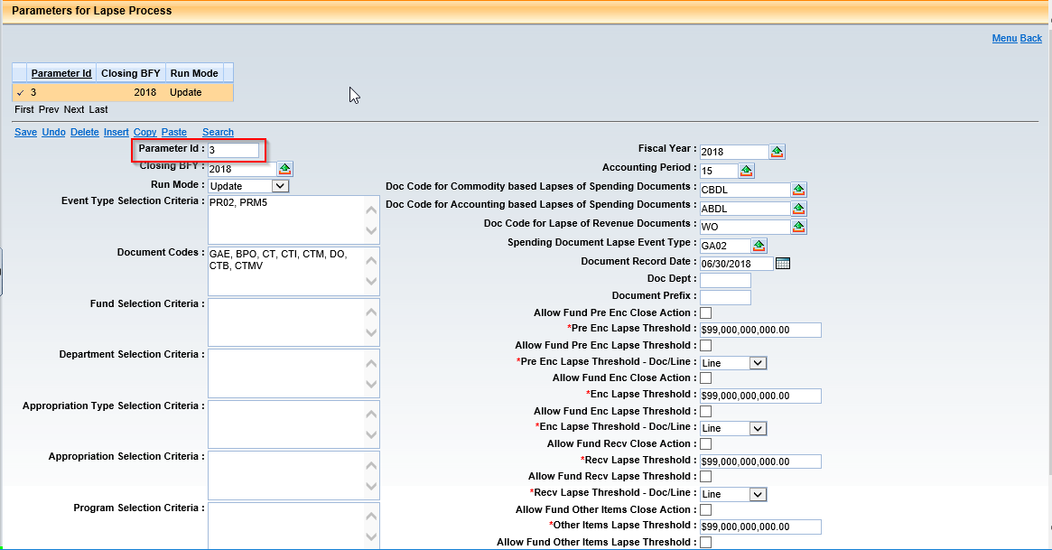

- Verify Modification Documents in Document Catalog
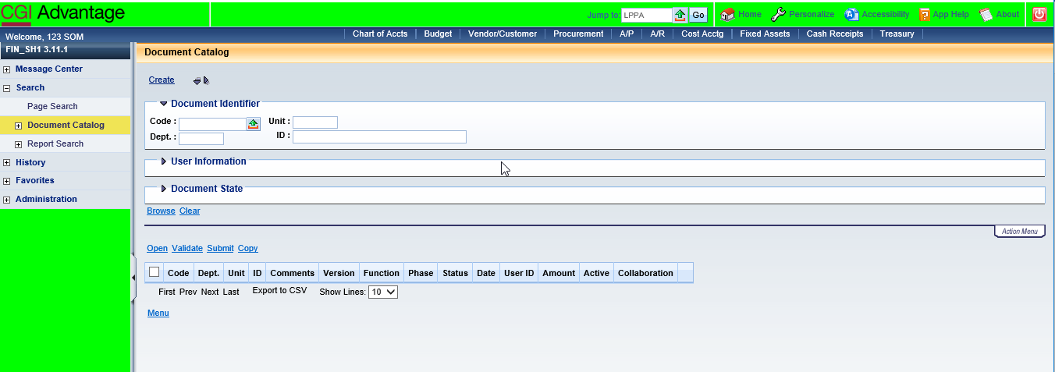

- Review Document Catalog to make sure that no document is left in draft status or have rejected.

- Reset MESG table – Set MESG A5074 severity to “Error”.
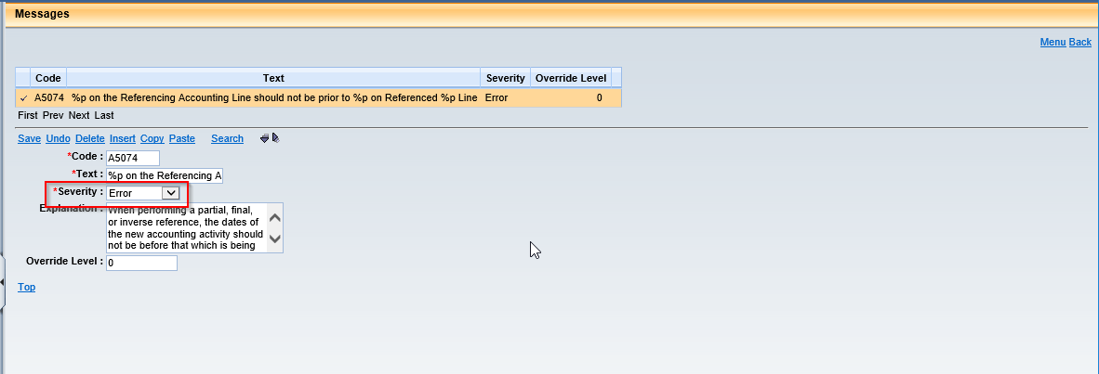

- Open Activity Lapse – PRM6

- Update DCTRL for ABDL, CBDL as below:
Vendor = Optional
Time Restriction Severity = Override
Time Restriction = No Limit
Override BFY Staging Allowed = True

- Update PROGREQ for all listed records
Program = Optional

- Update MESG table – Set A5074 severity to “Information”

- Add CBDL document to PRCUTYP 18 award section.

- Setup LPPA table as below:
Parm ID = 1
Closing BFY = 2018
Run Mode = Report Only
Doc Code = GAE, BPO, CT, CTI, CTM, DO, CTB, CTMV
Event Type Selection = PR02, PRM5, PRM6
Fiscal Year = 2018
Accounting Period = 15
Doc Record Date = 06/30/2018

- Schedule Open Activity Roll Chain job in Report Only Mode.

- Setup LPPA table as below:
Parm ID = 2
Closing BFY = 2018
Run Mode = Pre-Selection
Doc Code = GAE, BPO, CT, CTM, DO, CTB, CTMV
Event Type Selection = PR02, PRM5, PRM6
Fiscal Year = 2018
Accounting Period = 15
Doc Rec Date = 06/30/2018

- Schedule Open Activity Lapse Roll job in pre-Select Mode. (Disable all jobs except 1)

- Review RLPSD table and deselect any item that should not lapse.

- Setup LPPA table as below:
Parm ID = 3
Closing BFY = 2018
Run Mode = Update
Doc Code = BPO, CT, CTB, CTM, DO, GAE
Event Type Selection = PR02, PRM5
Fiscal Year = 2018
Accounting Period = 14
Doc Rec Date = 06/30/2018

- Schedule Open Activity Lapse job to create and submit documents (No Jobs disabled)

- Verify Modification Documents in Document Catalog

- Review Document Catalog to make sure that no lapsing documents are left in draft status or have rejected.

Open Activity Roll – Receivables (RE, REM)

- Confirm SOPT General settings.
FY = 2018
Recv Close Action = Roll
Recv Roll Min = $0.00

- Update DCTRL for RE, RES, REM documents as below:
Future Doc Date Allowed = True
Future Acctg Prd Allowed = True
Future FY Allowed = True
Past Acctg Prd Allowed = True
Past FY Allowed = True
Override BFY Staging Allowed = True
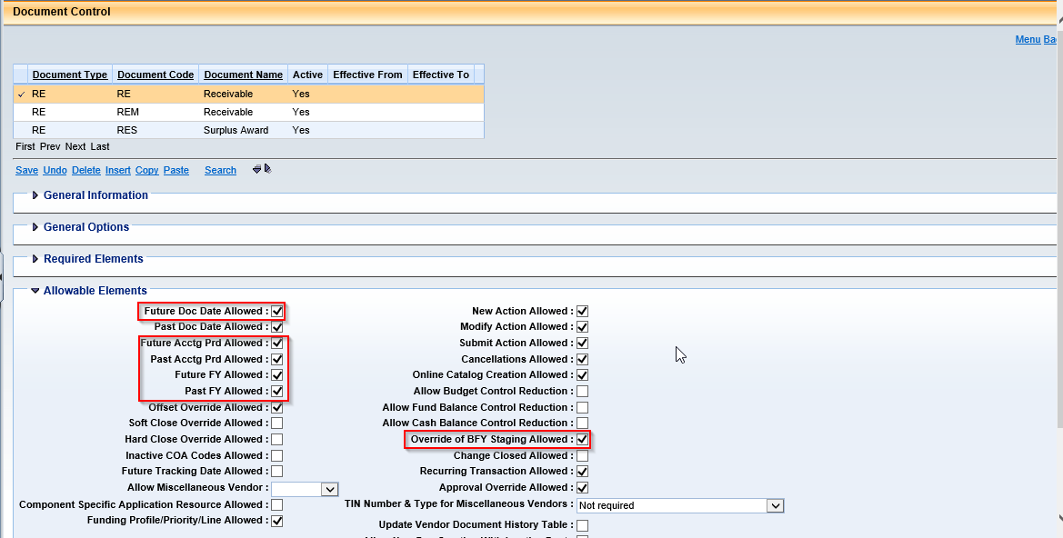

- Confirm APPCTRL settings
AR_REF_OPT = 1
BACKOUT_APD = 15
BACKOUT_FY = 2018
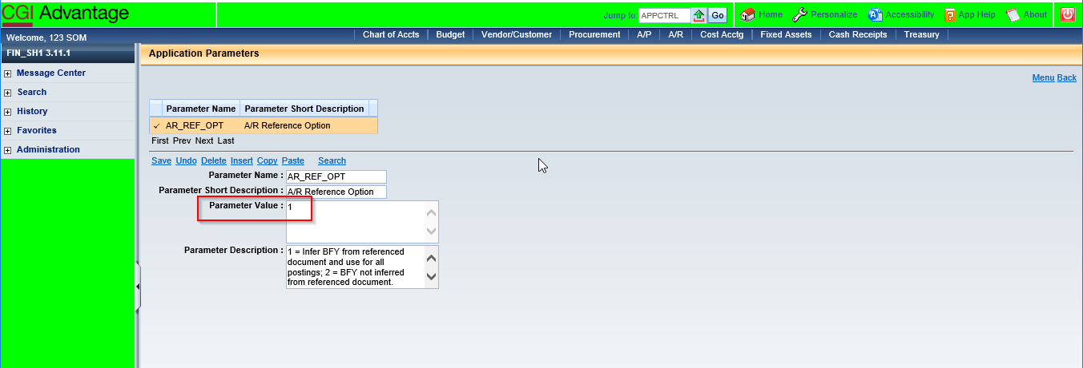

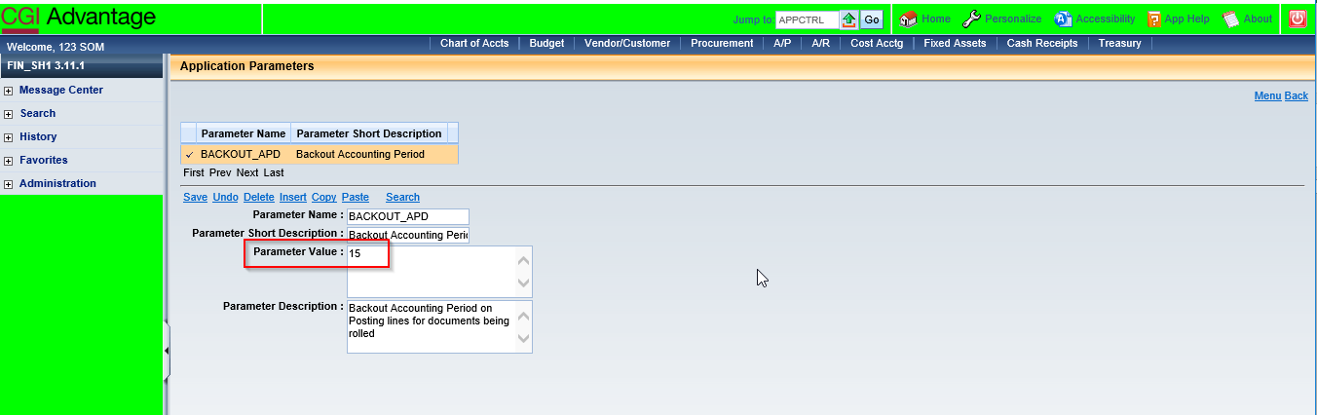

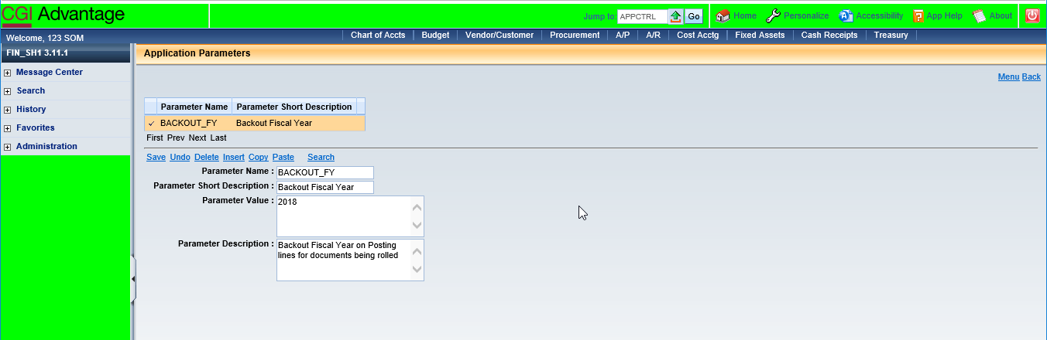

NOTE: Bounce server if APPCTRL parameters are updated.

- Update MESG table – Set A4150 severity to “Information”.
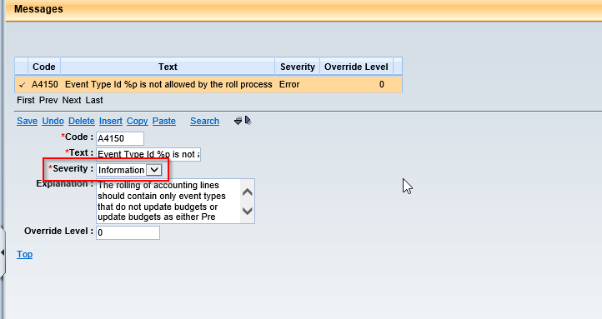

- Setup RLPA table as below:
Parm ID = 7
Closing BFY = 2018
Run Mode = Report Only
Event Type Selection = AR01, AR10, AR30, AR50, AR52, AR54, ARM1
Document Code = RE, RES, REM
Mod FY = 2018
Mod APD = 14
Adj Reason = YEROLL
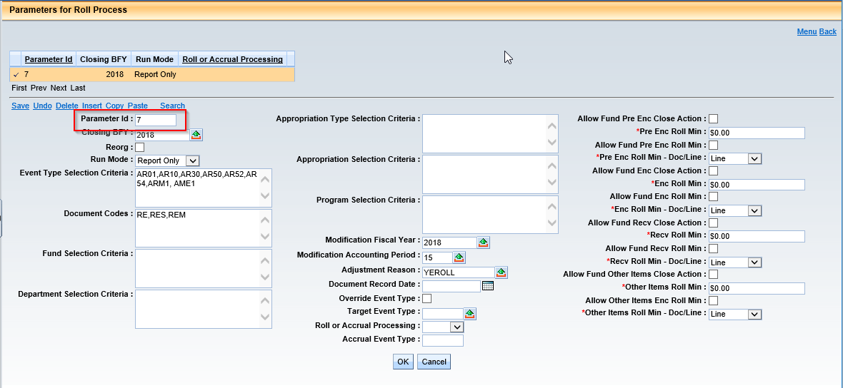

- Reject all pending RE documents from Document Catalog.
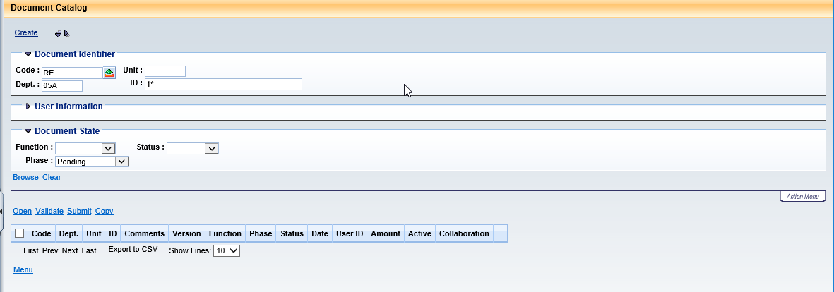

- Schedule Open Activity Roll job in Report Only mode

- Setup RLPA table as below:
Parm ID = 8
Closing BFY = 2018
Run Mode = Pre-Selection
Event Type Selection = AR01, AR10, AR30, AR50, AR52, AR54, ARM1
Document Code = RE, RES, REM
Mod FY = 2018
Mod APD = 14
Adj Reason = YEROLL
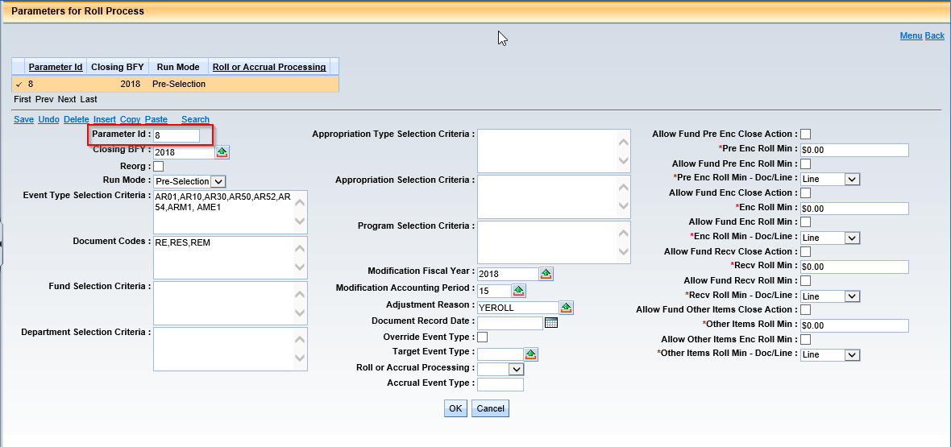

- Review RLPSD table and deselect if any item that should not roll.
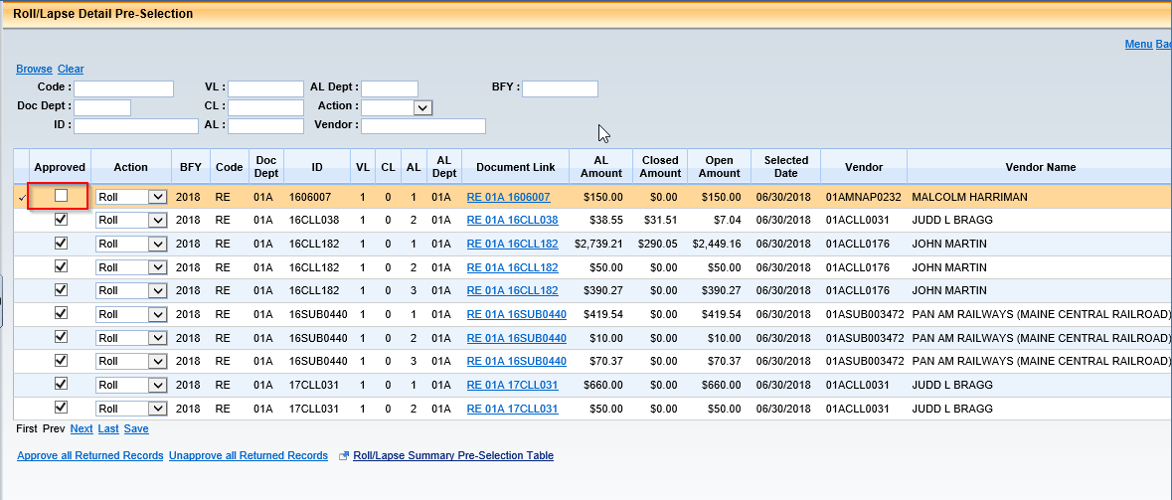

- Setup RLPA table as below:
Parm ID = 9
Closing BFY = 2018
Run Mode = Update
Event Type Selection = AR01, AR10, AR30, AR50, AR52, AR54, ARM1
Document Code = RE, RES, REM
Mod FY = 2018
Mod APD = 14
Adj Reason = YEROLL
Doc Rec Date = 07/01/2018
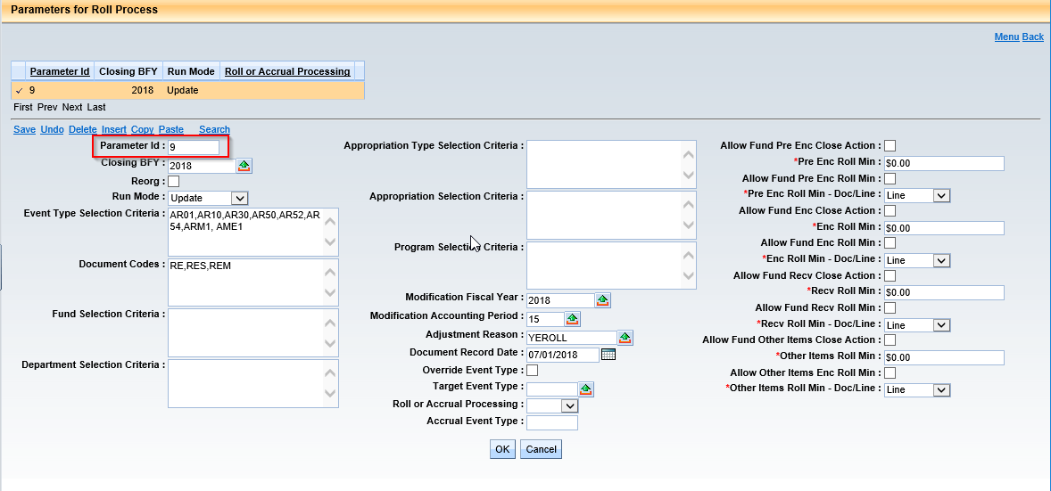

- Schedule Open Activity Roll job in Update Mode to create documents. (Disable all jobs except 1 and 2).

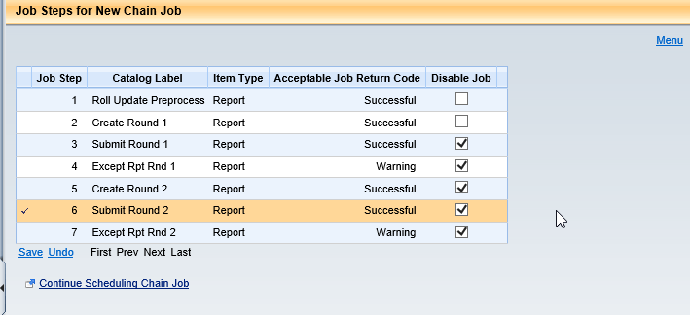

- Schedule Open Activity Roll in Update mode to Submit Documents. (Disable 1 and 2 jobs)

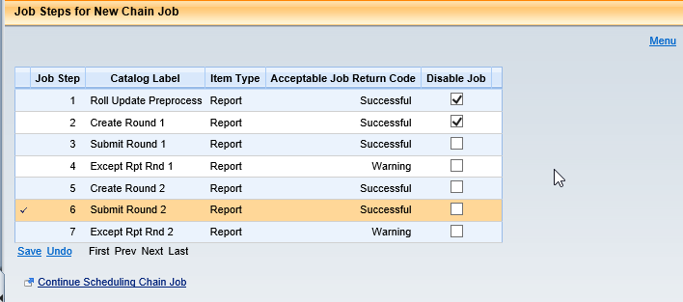

- Review Document Catalog to make sure that no RE, RES documents are left in draft status or have rejected.

- Update DCTRL for RE, RES, REM documents as below:
Future Doc Date Allowed = False
Future Acctg Prd Allowed = False
Future FY Allowed = False
Override BFY Staging Allowed = False
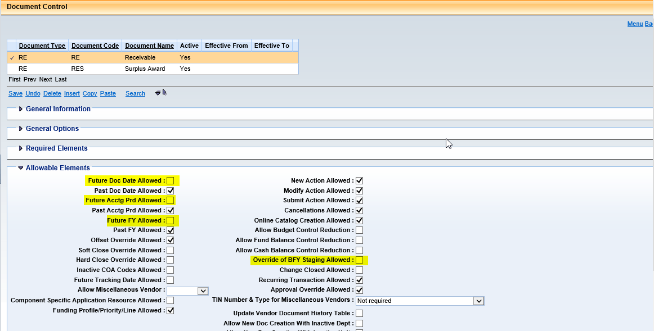

- Reset DCTRL to prohibit past accounting period, past fiscal year for normal transactions.
- Reverse Accounting for Encumbrance Roll.
Process JVA to reverse effect of encumbrance roll in closing BFY:
BFY = 2018
FY = 2018
APD = 15
Debit Encumbrance P005
Credit Reserve for Encumbrances
- Reverse Accounting for RE roll.
Process JVA to reverse effect of RE roll
- Reduce Allotment for lapsed encumbrance.
Process BGCA document to reduce AL balances related to lapsed encumbrances.

- Reset APPCTRL settings.
AR_REF_OPT = 2
BACKOUT_APD = Blank
BACKOUT_FY = Blank
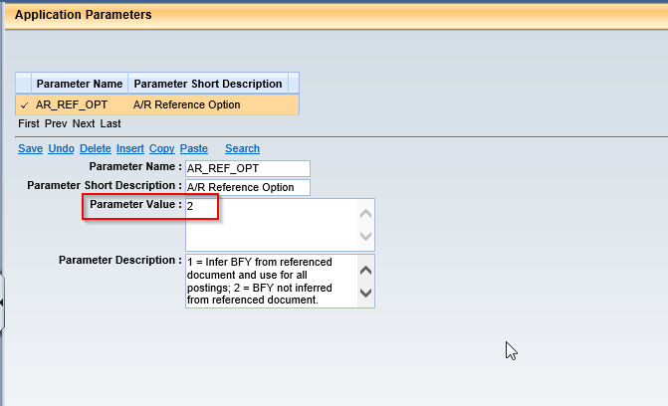
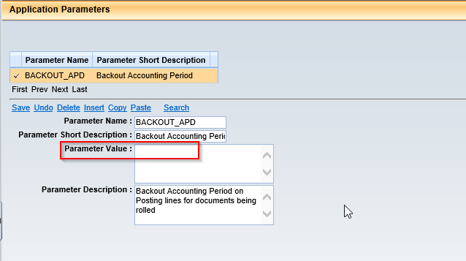
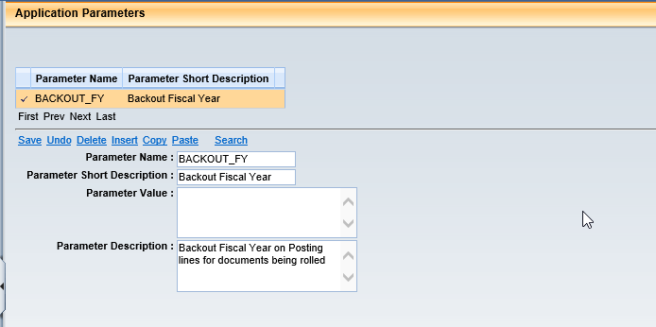

- Unlock Users.

